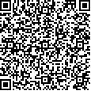
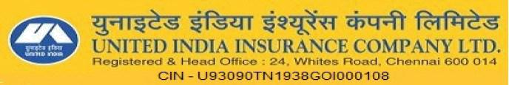
MOTOR INSURANCE - Two Wheeler PACKAGE POLICY SCHEDULE

 | Policy Number | :22140031170160011694 |  |  |  |  |  |  |  | Previous Policy Number |  | :1-3A66ZAL
 | Geographical Area |  | :India |  |  |  |  |  |  | Insurance Start Date & Time |  | :17/11/2017 0:00 (hours)
 | Insured Name |  | :Shivaraj Kumar |  |  |  |  |  |  | Insurance Expiry Date & Time |  | :19/11/2019 midnight
 | Insured Address | : |  |  |  |  |  |  |  | Policy Issuing Office Address |  | :
 | 50,thyavakanhalli,bideraguppesarjapura,anekal |  |  |  |  |  |  |  |  | DO 14 GURGAON 4, NEW COLONY, ABOVE SBI,
 | tq,bangalore |  |  |  |  |  |  |  |  | GURGAON
 | City | :BANGALORE |  |  | District |  | :BANGALORE |  |  | City | :GURGAON | District |  | :Gurgaon
 | State | :KARNATAKA |  |  | Pincode |  | :562107 |  |  | State | :HARYANA | Pincode |  | :122001
 | Mobile No | :8050930901 |  |  |  |  |  |  |  | Office Contact Details | :0124 2320650 | Email Id |  | :pb.support@uiic.co.in
 | Email | :shivakmraj@gmail.com |  |  |  |  |  |  |  | Fax | :0124 2300927 | GSTIN |  | :06AAACU5552C1ZN
 | Business Channel Code: |  |  | NA |  |  |  |  |  | Business Channel Sub Code: |  | BRC0000907
 | Contact No/Email: |  |  | 18002088787/crtmotor@policybazaar.com |  |  |  |  |  | Broker Name : |  | Policybazaar Insurance Web Aggregator Pvt. Ltd.
 | IRDA License Code - Number: |  |  | IRDAI/WBA21/15 - 06
 | VEHICLE DETAILS
 | Registration Number |  | KA51EE9637 |  |  | Engine Number |  |  |  | DHZCDK74132 |  | Year of Manufacture Vehicle |  | 2013
 | Registration Number |  |  |  |  | Engine Number |  |  |  |  |  | Weight(kg.) |  | 2013
 | RTA Name |  | KA51 Bengaluru |  |  | Chassis Number |  |  |  | MD2A11CZ6DCK78658 |  | Cubic Capacity / GVW |  | 150
 | Registration Date | 22/01/2013 |  |  |  | Vehicle Make & Model |  | Bajaj - PULSAR 150 DTSI - KICK START (150 CC) |  |  |  | Type of Body |  | Two Wheeler
 | AA Membership Name |  |  |  |  | Seating Capacity |  |  | 2 |  |  | Geographical Extension |  | NoExtn
 | INSURED DECLARED VALUE (IN RUPEES)
 | Vehicle |  | Trailer | FiberGlass |  | Electrical /Electronic |  |  | Non-Electrical |  | CNG Kit | LPG Kit | TOTAL | Co-Insurance
 | Vehicle |  | Trailer |  |  | Accessories |  |  | Accessories |  | CNG Kit | LPG Kit | TOTAL | Details
 | 28176 | 0 |  | 0 |  | 0.00 |  |  | 0.00 |  | 0.00 | 0.00 | 28176 | 0.00
 | OTHER DETAILS
 | Financier |  |  |  |  | Branch Name & Address |  |  |  |  | Policy Subject to IMT Endorsements/Applicable covers
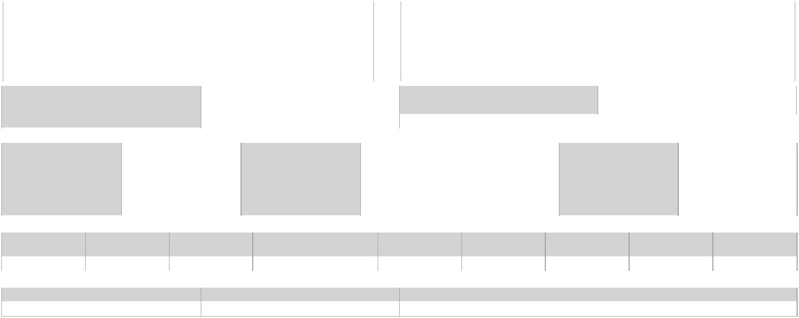

PERSONS OR CLASS OF PERSONS ENTITLED TO DRIVE: As narrated in the certificate of insurance attached herewith.

LIMITATIONS AS TO USE : As narrated in the certificate of insurance attached herewith.

LIMITS OF LIABILITY : As narrated in the certificate of insurance attached herewith.

OTHER DETAILS
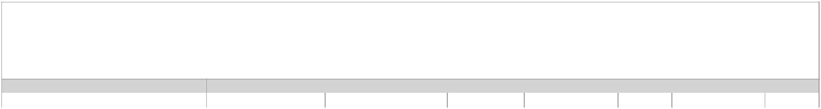

EXCLUSIONS: (1) Any accidental loss or damage and/or liability caused sustained or incurred outside the geographical area. (2) Any claim arising out of any contractual liability. (3) Any accidental loss or damage to any property whatsoever or any loss or expense whatsoever resulting or arising there from or any consequential loss. (4) Any liability of whatsoever nature directly or indirectly caused by or contributed to or by arising out of ionizing radiations or contamination by radioactivity from any nuclear fuel. For the purpose of this exception, combustion shall include any self sustaining process of nuclear fission. (5) Any accidental loss or damage or liability directly or indirectly caused by or contributed to, by or arising from nuclear weapons material. (6) Any accidental loss, damage or liability directly or indirectly or proximately or remotely occasioned by contributed to by or traceable to or arising out of or in connection with war, invasion, the act of foreign enemies, hostilities or war like operations(whether before or after declaration of war), civil war, mutiny, rebellion, military or usurped power or by any direct or indirect consequence of any of the said occurrences or any consequences thereof and in default of such proof, the company shall not be liable to make any payment in respect of such a claim.

PA COVER CSI (In Rupees) |  |  |  | DEDUCTIBLES (Under Section I) (In Rupees)
Owner- Driver (Under section IV) |  | 1,00,000.00 |  | Compulsory | 100.00 |  | Imposed | 0.00 | Voluntary | 0.00
SCHEDULE OF PREMIUM (IN RUPEES)
A-OWN DAMAGE PREMIUM |  |  |  | B-LIABILITY PREMIUM |  |  |  | TOTAL PACKAGE PREMIUM
Basic Own Damage |  | 192 | Basic TP Liability |  |  | 720 | Package Premium |  |  | 875
Anti Theft Device Discount |  |  | PA Owner Driver |  |  | 50 | GST @18.00% |  |  | 158
Nil depreciation withoutExcess |  | 0 | PA for Unnamed persons
Sub Total(Additions) |  | 0 | Sub Total (Additions)
NCB Discount @ 45 % |  | 87 | Sub Total (Deductions) |  |  | 0
Total |  | 105 | Total |  |  | 770
 |  |  |  |  |  |  | TOTAL PAYABLE PREMIUM |  |  | 1033
 |  |  |  |  |  |  | Receipt Date |  |  | 13/07/2017
 |  |  |  |  |  |  | Receipt Amount |  |  | 1033
 |  |  |  |  |  |  | Payment Mode |  |  | Online
 |  |  |  |  |  |  | Paying Party |  |  | Shivaraj Kumar
CHEQUE DETAIL
Cheque Number | Cheque Date | Bank Name |  | Branch Name |  | Branch Code |  | Cheque Signatory |  | MICR No
493538 | 17/11/2017 | STANDARD CHARTERED |  |  |  |  |  | Shivaraj Kumar
493538 | 17/11/2017 | BANK |  |  |  |  |  | Shivaraj Kumar
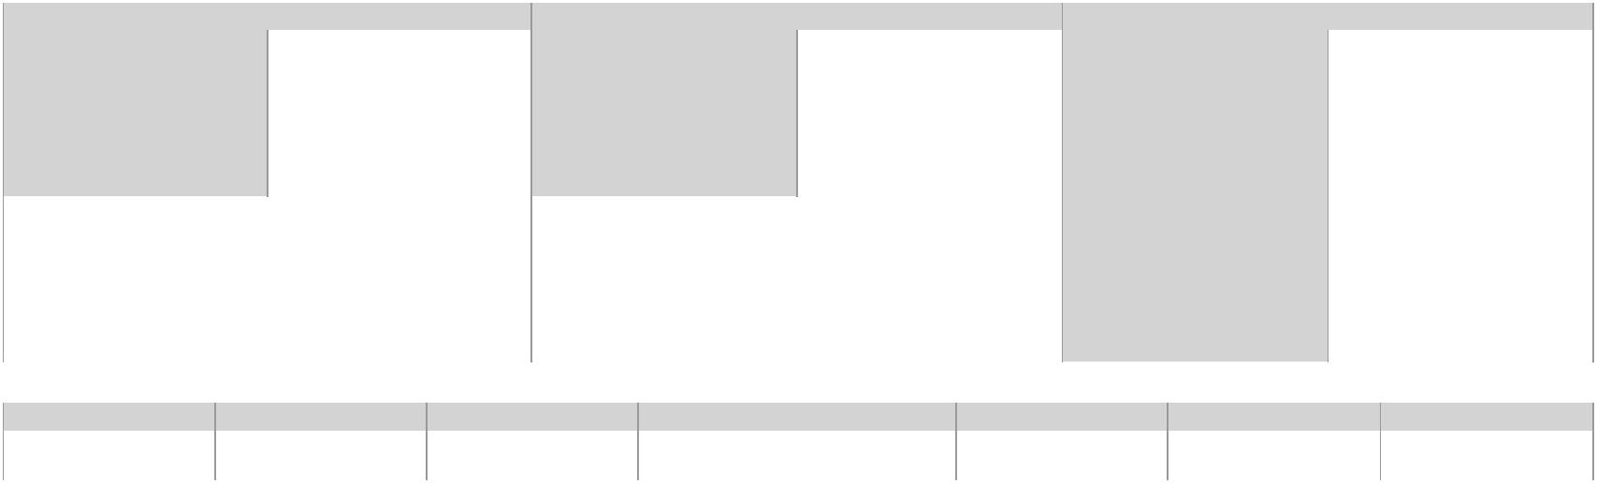

TERMS & CONDITIONS: As per the Indian Motor Tariff, personal copy of the same is available free of cost on request. Further the Indian Motor Tariff is also available and displayed at allUnited India Insurance Company Offices and on website http://uiic.co.in/sites/default/files/uploads/downloadcenter/IndianMotorTariff.pdf.

For terms and conditions for add on covers go to : http://uiic.co.in/sites/default/files/uploads/downloadcenter/motor_additional_covers.pdf

DISCLAIMER: The policy stands cancelled or void in the event of Cheque Dishonored. The company may cancel the policy by sending 7 days notice in case of fraud, misrepresentation, nondisclosure of material fact or non co-operation of the insured.

IMPORTANT NOTICE : The Insured is not indemnified if the vehicle is used or driven otherwise than in accordance with this Schedule. Any payment made by the Company by reason ofwider terms appearing in the Certificate in order to comply with the Motor Vehicle Act, 1988 is recoverable from the Insured. See the clause headed "AVOIDANCE OF CERTAIN TERMS ANDRIGHT OF RECOVERY". For Legal interpretation, English version will hold good. In case of accident, the insured must inform United India Insurance Co. Immediately to arrange spot survey.Date & Signature of Proposal: 13/07/2017 00:00:00.0

In Witness whereof this Policy has been signed at GURGAON this day of , Date

For United India Insurance Company Limited


 |  | Affix
 |  | policy
 |  | stamp | Duly Constituted Attorneys
IP Address: | 180.151.248.82
 |  |  | Print Date: 17/11/2017 15:24:02
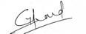

United India Insurance Company Ltd : IRDA Reg: No : 545

Underwritten by Policy Bazaar on 17/11/2017 15:24:02

* This is a system generated document and any manual alteration / correction / overwriting in the document will make it invalid.

